User Agent Programming

This document will explain what our Multi User Agent system (MAS) simulates as well as how the communication between agents works.

# What it simulates and how it works

Our MAS system will simulate a post office. In the post office will be sitting one or multiple agents with letters to be distributed. These post office agents can contact delivery agents the hand out the letters and thereby making sure the letters are getting delivered.  
Every post office agent will decide what delivery agent will be the best for distributing letters at that specific time.

The delivery agents will all have a work schedule. Every agent will work for a certain amount of hours and thereby has only a certain amount of hours left to work. Also every delivery agent will keep track of how many letters he has at any given time.

The post office agents will hand out the letters to the agent they think is best by comparing the work time and letters every delivery agent has at that moment. Asking everybody the information it will decide which one will get the letter (and become the chosen one) and the process will repeat with every letter that needs to be distributed.

The formula the post office agent will use to decide which agent is the chosen one will look as follows:  
rating of the agent = time – letters  
  
where time will be the available work time left of the agent and letters how many letters this agent is holding at this moment.

# Flow chart of our system

Below is a basic flow chart of our system in finding the chosen one:

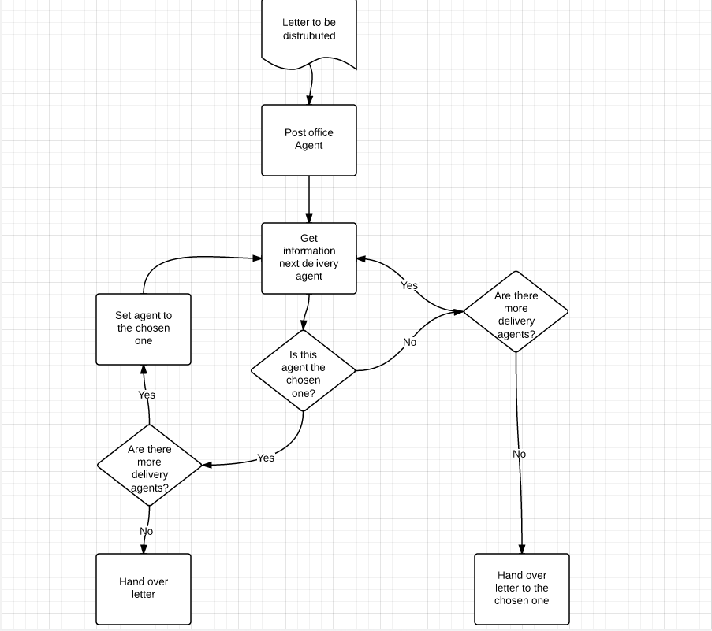

For every batch of letters the post office agent will get the information from the delivery agent. As stated before this information will contain the amount of letters said delivery agent has and the available work time left this delivery agent. It will then check if there are more agents left and either hand over the letter to the agent immediately or to the chosen one found before.

# Communication between agents

Below is basic communication diagram between the agents:

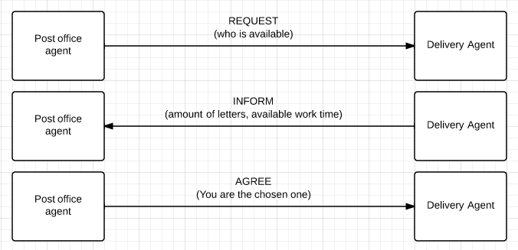

The post office agent will REQUEST all the agents to perform the task at hand. Every delivery agent will then respond with an INFORM containing how many letters it has at the current time and the amount of work time left. By comparing the agents with each other, the post office agent will decide who will be the chosen one to deliver this letter.   
He will respond to the chosen one with an AGREE to hand over the letter to this agent.